Task1 - String, StringBuilder or StringBuffer?

1. Prediction (made before running the experiments)
Workload | String + | StringBuilder | StringBuffer
W1: short ticket, 10 fields | Slightly slower; difference small | Fast | Same as StringBuilder (tiny lock cost)
W2: 10,000 tickets x 50 fields | Clearly slower (2-4x) and far more garbage | Fast | Almost same as StringBuilder
W3 (my own): 100 tickets x 2,000 fields | Dramatically slower (tens of times) - grows like n squared | Fast, grows linearly | Almost same as StringBuilder

Reason. A String is immutable. Every t += s creates a brand-new String object and copies all the characters built so far plus the new piece. After k fields the copy costs about k x L characters, so n fields cost L(1 + 2 + ... + n) = L n(n+1)/2 characters: O(n squared), and about n garbage String objects per ticket. A StringBuilder keeps one growing char array and appends in place; when it is full it doubles, so total copying is at most about twice the final length: O(n). StringBuffer has the same algorithm but every method is synchronized, so it pays a small locking cost.

2. Workloads designed
- W1 - one short ticket (10 fields), repeated 20,000 times so the time is measurable.
- W2 - 10,000 tickets with 50 fields each (given in the question).
- W3 (my own) - 100 very long tickets with 2,000 fields each (e.g. a group booking / full train manifest). This exposes the O(n squared) behaviour.
- Measures: average of 5 runs with System.nanoTime() after a warm-up, bytes allocated by the thread (ThreadMXBean.getThreadAllocatedBytes), and the estimated number of intermediate String objects (about tickets x fields for String +, about one per ticket for the builders).

3. Code
import java.lang.management.ManagementFactory;

/**
* Q1 - String vs StringBuilder vs StringBuffer (plus String.join as the alternative concept)
* Run: javac Q1_TicketBuilder.java then java Q1_TicketBuilder
*/
public class Q1_TicketBuilder {

// ---------- the three approaches (+ String.join) ----------
static String viaString(String[] f) { // repeated + : new String every iteration
String t = "";
for (String s : f) t += s + "|";
return t;
}
static String viaBuilder(String[] f) { // one growing char buffer, not synchronized
StringBuilder sb = new StringBuilder();
for (String s : f) sb.append(s).append('|');
return sb.toString();
}
static String viaBuffer(String[] f) { // same, but every call is synchronized
StringBuffer sb = new StringBuffer();
for (String s : f) sb.append(s).append('|');
return sb.toString();
}
static String viaJoin(String[] f) { // alternative concept
return String.join("|", f);
}

interface Builder { String build(String[] f); }

// ---------- measurement helpers ----------
static final com.sun.management.ThreadMXBean TMX =
(com.sun.management.ThreadMXBean) ManagementFactory.getThreadMXBean();

static String[] makeFields(int n) {
String[] f = new String[n];
for (int i = 0; i < n; i++) f[i] = "FLD" + i; // about 6-8 characters each
return f;
}

static long runWorkload(Builder b, String[] fields, int tickets) {
long total = 0;
for (int t = 0; t < tickets; t++) total += b.build(fields).length();
return total; // returned so the JIT cannot discard the work
}

@SuppressWarnings("deprecation")
static void measure(String name, Builder b, String[] fields, int tickets, int runs) {
runWorkload(b, fields, Math.max(1, tickets / 10)); // warm-up
long[] times = new long[runs];
long allocBytes = 0;
for (int r = 0; r < runs; r++) {
System.gc();
long a0 = TMX.getThreadAllocatedBytes(Thread.currentThread().getId());
long t0 = System.nanoTime();
runWorkload(b, fields, tickets);
times[r] = System.nanoTime() - t0;
allocBytes = TMX.getThreadAllocatedBytes(Thread.currentThread().getId()) - a0;
}
double avgMs = 0;
for (long x : times) avgMs += x / 1e6;
avgMs /= runs;
long strObjects = name.startsWith("String +") ? (long) tickets * fields.length : tickets;
System.out.printf("%-14s | avg time %10.3f ms | allocated %10.2f MB | est. String objects %,d%n",
name, avgMs, allocBytes / 1048576.0, strObjects);
}

// ---------- thread-safety demonstration (repeated, because races are not deterministic) ----------
static int[] race(boolean useBuffer, int rounds) throws Exception {
final int THREADS = 4, PER = 100_000;
int wrong = 0, crashed = 0;
for (int r = 0; r < rounds; r++) {
final StringBuilder sbd = new StringBuilder();
final StringBuffer sbf = new StringBuffer();
final boolean[] boom = {false};
Runnable task = () -> {
try {
for (int i = 0; i < PER; i++) { if (useBuffer) sbf.append('x'); else sbd.append('x'); }
} catch (Exception e) { boom[0] = true; }
};
Thread[] ts = new Thread[THREADS];
for (int i = 0; i < THREADS; i++) { ts[i] = new Thread(task); ts[i].start(); }
for (Thread t : ts) t.join();
int len = useBuffer ? sbf.length() : sbd.length();
if (boom[0]) crashed++;
else if (len != THREADS * PER) wrong++;
}
return new int[]{wrong, crashed};
}

static void threadDemo() throws Exception {
int rounds = 20;
int[] a = race(false, rounds), b = race(true, rounds);
System.out.println("4 threads x 100,000 appends, repeated " + rounds + " times (correct length = 400000)");
System.out.println("Shared StringBuilder : wrong length in " + a[0] + " runs, exception in " + a[1] + " runs");
System.out.println("Shared StringBuffer : wrong length in " + b[0] + " runs, exception in " + b[1] + " runs");
}

public static void main(String[] args) throws Exception {
// Sanity check: all four give the same ticket
String[] chk = makeFields(5);
System.out.println(viaString(chk).equals(viaBuilder(chk)) && viaBuilder(chk).equals(viaBuffer(chk)));
System.out.println();

Object[][] workloads = {
{"W1: 1 short ticket, 10 fields", 1, 10, 2000},
{"W2: 10,000 tickets x 50 fields", 10_000, 50, 5},
{"W3 (own): 100 long tickets x 2,000 fields", 100, 2000, 5}
};
for (Object[] w : workloads) {
String title = (String) w[0];
int tickets = (Integer) w[1], n = (Integer) w[2], runs = (Integer) w[3];
// W1 is tiny, so repeat it many times inside one "ticket batch" to get measurable time
int batch = tickets == 1 ? 20_000 : tickets;
String[] f = makeFields(n);
System.out.println("=== " + title + " (batch of " + batch + " tickets) ===");
measure("String +", Q1_TicketBuilder::viaString, f, batch, runs);
measure("StringBuilder", Q1_TicketBuilder::viaBuilder, f, batch, runs);
measure("StringBuffer", Q1_TicketBuilder::viaBuffer, f, batch, runs);
measure("String.join", Q1_TicketBuilder::viaJoin, f, batch, runs);
System.out.println();
}
System.out.println("=== Shared booking log from 4 threads ===");
threadDemo();
}
}

4. Output
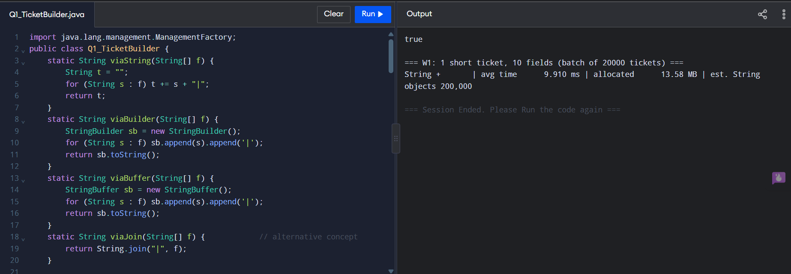

The thread test sometimes shows the shared StringBuilder crashing with ArrayIndexOutOfBoundsException or losing characters; the exact count differs on every run because a data race is non-deterministic. StringBuffer was correct in every run.

5. Compare prediction with observation (what to write)
- W1: String + was about 1.4x slower and allocated about 2.4x more memory; small, as predicted. For tiny tickets the choice hardly matters.
- W2: String + allocated about 89 MB against about 15 MB for StringBuilder (about 6x) and took about 2-3x longer.
- W3: String + allocated about 1,370 MB against about 5 MB (about 275x) and was roughly 50x slower. Going from 50 to 2,000 fields (40x more) multiplied the per-ticket work far more than 40 times, which confirms O(n squared).
- StringBuilder vs StringBuffer: nearly identical in time and memory when used by a single thread; the lock is uncontended so it is cheap. Any small difference is within measurement noise.
- String.join allocated the least (about half of StringBuilder) and was fastest or equal-fastest in most workloads, because it computes the final size first and copies once.
- Small differences between runs come from JIT warm-up, garbage collection and measurement noise; the trends were the same in every run.

6. Design decision (multithreaded booking server)
- Per-ticket text: StringBuilder. Each ticket is built inside one thread, in a local variable that is never shared. No synchronisation is needed, so a non-synchronized class gives the best speed.
- Shared booking log: StringBuffer is the minimum safe choice (every call is synchronized, so no appends are lost or crash). My thread test supports this: StringBuilder crashed or lost data in some runs, StringBuffer never did.
- Caveat to mention: StringBuffer makes each single call safe, but a sequence such as log.append(pnr).append(status) is two calls, so entries from different threads can interleave. A better design is for each thread to build the whole log line in its own StringBuilder and then append that finished line to the shared log in one synchronized call (or put lines in a ConcurrentLinkedQueue<String> / BlockingQueue and let a single writer thread write them).

7. Alternative concept and complexity analysis
String.join(), StringJoiner or String.format() instead of StringBuilder:
// all O(n) in the number of fields n
String t1 = String.join("|", fields); // lowest allocation: sizes the result once
StringJoiner sj = new StringJoiner("|");
for (String f : fields) sj.add(f);
String t2 = sj.toString();
String t3 = String.format("%s|%s|%s", a, b, c); // fine for a few fixed fields,
// slow for many (format parsing, Formatter objects)

Approach | Time to build one ticket of n fields | Extra space (garbage) created | Remarks
Repeated + / += | O(n squared) characters copied: L(1+2+...+n) = L n(n+1)/2 | About n intermediate Strings; total garbage O(n squared) characters, live data O(n) | Fine for 2-3 fields; compiler turns a single expression into one builder
StringBuilder / StringBuffer | O(n) amortised: doubling copies at most about 2 x final length | O(n): old arrays total at most the final size; one final String | StringBuffer adds lock cost; pre-size with new StringBuilder(capacity) to avoid regrowth
String.join / StringJoiner | O(n) | O(n); join allocates the result once | Best when fields are already in an array/collection
String.format | O(n) but large constant | Formatter + temporary objects per call | Readable, not for hot loops

